Raspberry Pi Air and Noise Pollution Monitoring System Over IOT
In recent day scenario, the non-stop increase in air and sound pollution prove to be an big alarming problem. It has become mandatory to control and appropriately monitor the situation so that the required steps to control the situation can be undertaken. In this project, an IOT-based method using RasberryPi is used to monitor and check live the Air Quality Index and the sound pollution of a region, have been proposed. The recommended technology comprises of two modules namely, the Air Quality Index Monitoring Module, the Sound Intensity Detection Module. Firstly, the Air Quality Index is measured considering the presence of the air pollutants. Then the sound intensity is detected using respective sensor. System uses air sensors to sense presence of harmful gases/compounds in the air and constantly transmit this data to microcontroller. Also system keeps measuring sound level and reports it to the online server over IOT. The sensors interact with microcontroller which processes this data and transmits it over internet. This allows authorities to monitor air pollution in different areas and take action against it. Also authorities can keep a watch on the noise pollution near schools, hospitals and no honking areas, and if system detects air quality and noise issues it alerts authorities so they can take measures to control the issue.

Block Diagram:

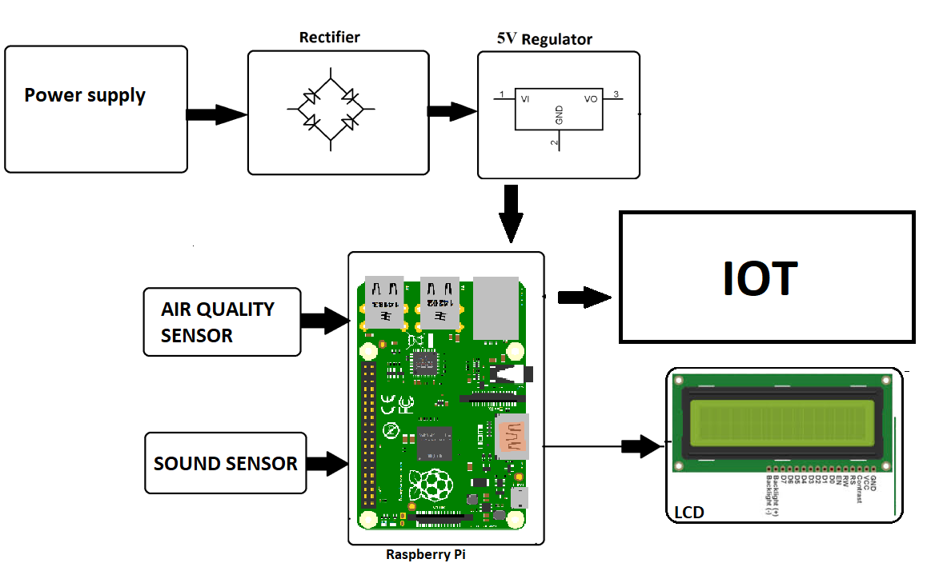

Hardware Specifications :
- Air Pollution Sensors
- Sound Sensors
- RaspberryPi
- LCD Display
- LED’s
- Adapter
- Resistors
- Capacitors
- Diodes

Software Specifications :
- Linux
- Programming Language: Python

